**Assignment 6**

In this assignment, the purpose is to use provided data to construct the three Natural Cubic Splines and three Clamped Cubic Splines.

The Natural Cubic Splines and Clamped Cubic Splines method algorithms, gotten form Numerical analysis tenth edition, written by RICHARD L. BURDEN, DOUGLAS J. FAIRES, ANNETTE M. BURDEN, (2014), section 3.5, algorithm 3.4 (page 147-148) and 3.5 (page 152-153), respectively, were used to get the corresponding equation in different intervals. The polynomials are in form of:



**Clamped Cubic Splines**

Some 1xn matrices in the MatLab were created to save each coefficient of each curve. Constructed polynomials are left below, used algorithm 3.5, plotted by clamped cubic splines-approximate graph is colored by “blue” below:

**Natural Cubic Splines**

Almost the same idea as above, used algorithm 3.4, constructed polynomials are left below, plotted by clamped cubic splines-approximate graph is colored by “red” below:

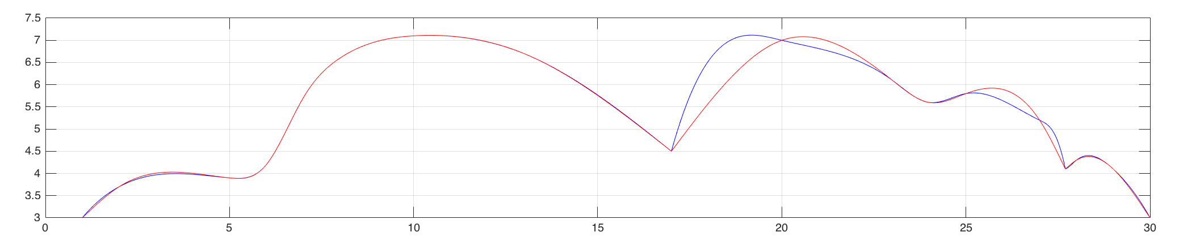

*The back of this noble beast by using clamped and natural cubic spline interpolants.*

*y-axis*

*x-axis*

Red: Natural Cubic Splines

Blue: Clamped Cubic Splines

Since the clamped and natural cubic spline interpolant graphs were plotted in the same graph, it was apparent to demonstrate their difference, though they matched nicely in the x’s interval from 1 to 17. However, there was a large difference in the x’s interval from 17 to 30 and only several points matched perfectly. The reason why the differences caused were that the method of natural splines was set by the second derivatives of S(x) at start point and end point are zero. On the other hand, the method of clamped spline was set by the the first derivatives of S(x) at start point and end point is equal to the first derivative of f(x) at start point and end point, respectively.

Allen Qian

ID: 301243658